Lab 2: Understanding Partitions, Keys, and Consumer Groups

Table of Contents
Table of Contents 2
Introduction 3
Learning Objectives 3
Prerequisites 3
Part 1 — Creating a Multi-Partition Topic 4
Step 1 — Create the Topic 4
Step 2 — Describe the Topic 4
Part 2 — Producing Messages with Keys 6
Step 1 — Produce Keyed Messages 6
Step 2 — Enter Your Data 6
Step 3 — See Where the Data Landed 7
Part 3 — Consumer Groups and Offsets 8
Step 1 — Start a Consumer Group 8
Step 2 — Resume the Consumer Group 9
Part 4 — Inspecting Consumer Group Lag 9
Step 1 — Produce More Data 9
Step 2 — Check the Group Status 9
Step 3 — Catch Up 10
Knowledge Check 11
Conclusion 11

Introduction
In Lab 1, you created a simple topic and sent a basic text message. However, the true power of Redpanda lies in its ability to process massive streams of data in parallel.
To achieve this parallelism, Redpanda divides topics into Partitions. When you produce data, you can assign a Key to a message to guarantee order for specific entities (like a specific user ID). Finally, Consumer Groups allow multiple applications to share the workload of reading those partitions while Redpanda keeps track of where they left off using Offsets.
In this lab, you will use the rpk CLI to see exactly how data distribution and offset tracking work under the hood.

Learning Objectives
Upon completing this lab, you will be able to:
- Create a topic with multiple partitions.
- Produce keyed messages and observe partition hashing.
- Consume messages from specific partitions.
- Launch a Consumer Group and understand how workload is shared.
- Inspect Consumer Group offsets and lag using rpk.

Prerequisites
- Completion of Lab 1.
- An active connection to your Redpanda Serverless cluster.
- Ensure you are logged in via the CLI (rpk cloud login or your configured profile).

Part 1 — Creating a Multi-Partition Topic
By default, quick-start topics might only have one partition. Let's explicitly create a topic designed for parallel processing.

Step 1 — Create the Topic
Run the following command to create a topic named web-clicks with 3 partitions:
rpk topic create web-clicks -p 3


Step 2 — Describe the Topic
Verify that your topic was created correctly:
rpk topic describe web-clicks
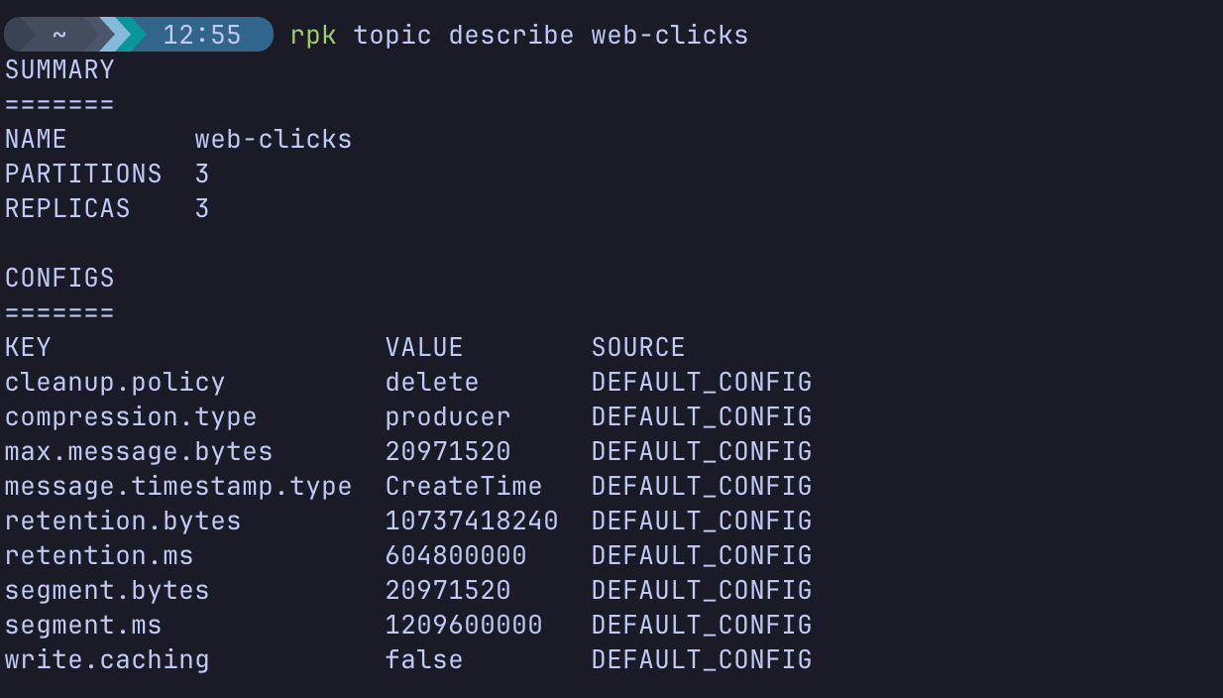

Observe the Output:
Look at the SUMMARY section at the top of the output. You will see PARTITIONS 3. This confirms Redpanda has successfully divided the topic into three independent, append-only logs that will run in parallel.

Part 2 — Producing Messages with Keys
When you send messages without a key, Redpanda distributes them round-robin across all available partitions. When you do provide a key, Redpanda uses a hashing algorithm to ensure that messages with the same key always go to the same partition. This guarantees exact ordering for specific data (e.g., all clicks from UserA are processed in order).

Step 1 — Produce Keyed Messages
We will use the rpk flag -f (format) to tell the CLI how to parse our input into Keys and Values. Run the following command:
rpk topic produce web-clicks -f "%k,%v\n"
(This tells rpk to expect input formatted as Key,Value followed by a new line).

Step 2 — Enter Your Data
Now, type the following lines into your terminal, pressing Enter after each one:
user_1,clicked_homepage
user_2,clicked_pricing
user_1,clicked_checkout
user_3,clicked_support
user_2,clicked_upgrade
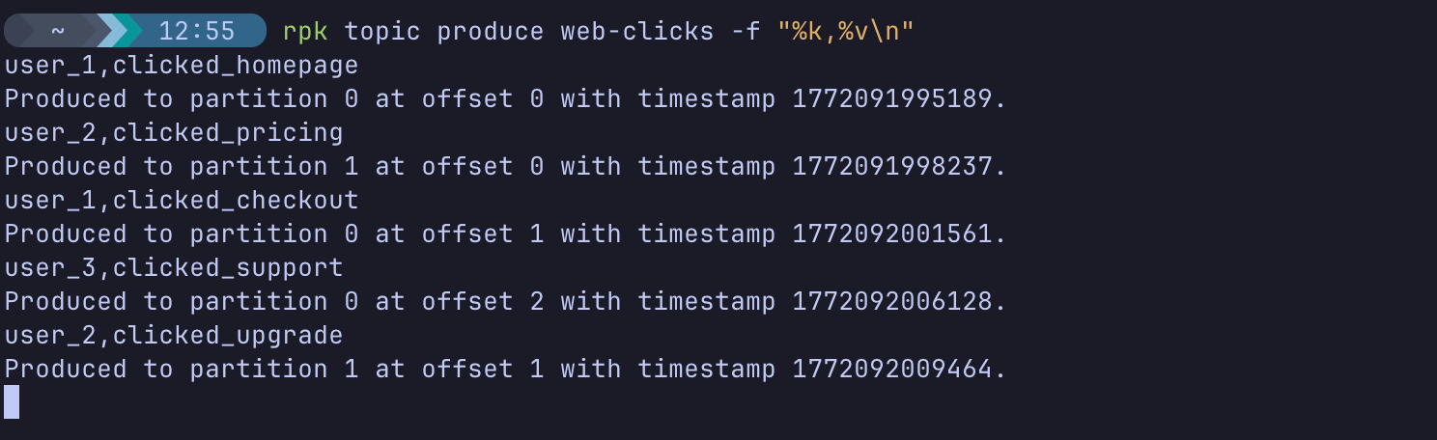
Press Ctrl+C when you are done to exit the producer.

Step 3 — See Where the Data Landed
Let's look at exactly how Redpanda routed those messages. Consume the entire topic, printing the partition number alongside the key and value:
rpk topic consume web-clicks -f "Partition: %p | Key: %k | Value: %v\n"
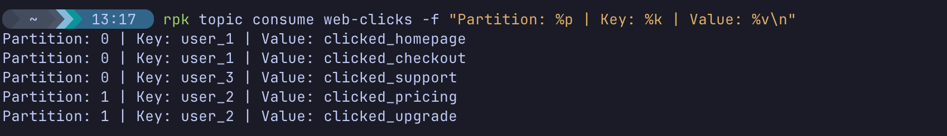
Observe the Output:
- Notice that user_1's actions (clicked_homepage, clicked_checkout) are guaranteed to be in the same partition.
- user_2's actions are also grouped together, likely in a different partition than user_1.
- Press Ctrl+C to exit.

Part 3 — Consumer Groups and Offsets
If you run rpk topic consume by itself, you act as an independent reader. If you disconnect and reconnect, you either start from the very beginning or the very end.
Consumer Groups solve this by saving your place (the Offset). If a consumer crashes and restarts, it resumes exactly where it left off.

Step 1 — Start a Consumer Group
Start a consumer and assign it to a group named analytics-engine:
rpk topic consume web-clicks -g analytics-engine
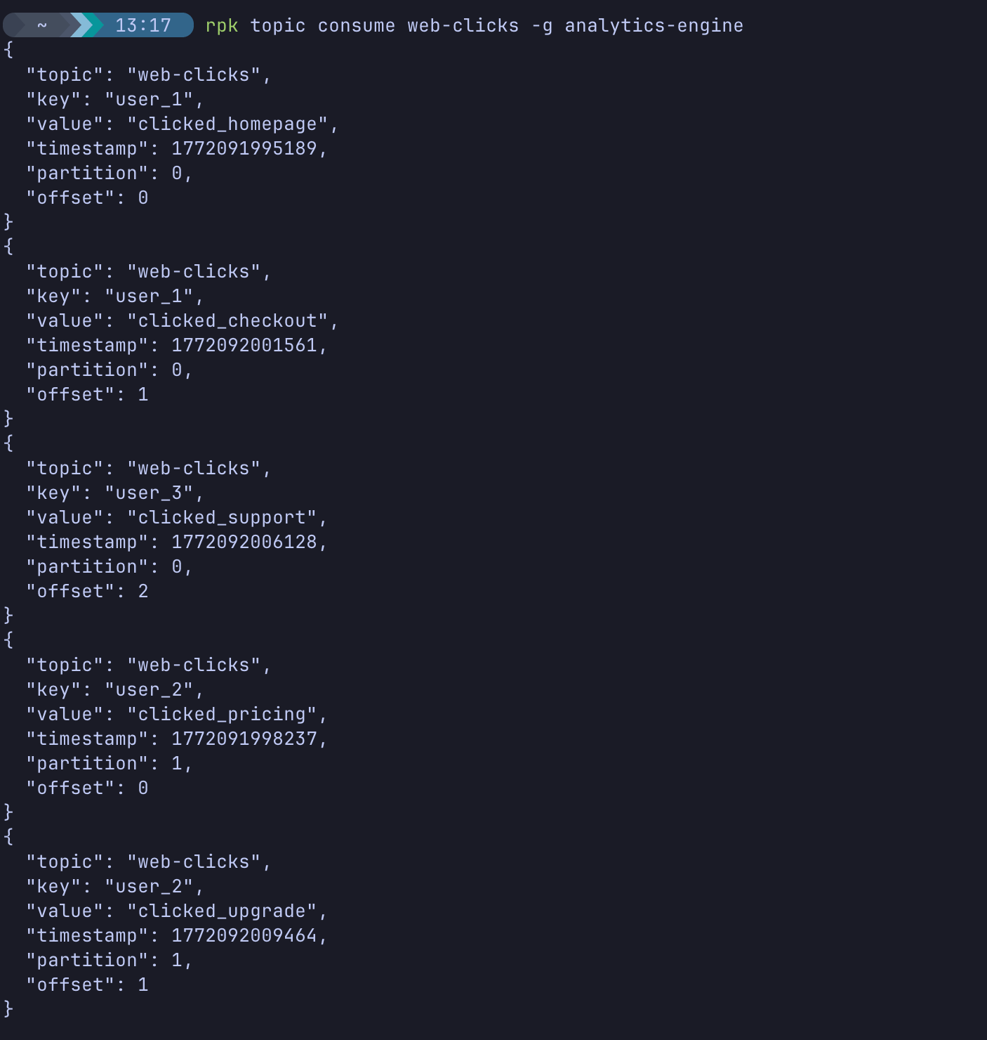
Because this is a new group, it will read all the messages you just produced.
Leave this terminal window running for a moment, then press Ctrl+C to stop it.

Step 2 — Resume the Consumer Group
Run the exact same command again:
rpk topic consume web-clicks -g analytics-engine
Observe: Nothing prints out! Why? Because Redpanda remembered that the analytics-engine group already read those offsets. It is now waiting for new data.
Press Ctrl+C to exit.

Part 4 — Inspecting Consumer Group Lag
What happens if data arrives while your consumer application is offline?

Step 1 — Produce More Data
While your consumer group is OFFLINE (you pressed Ctrl+C), produce a few more messages:
rpk topic produce web-clicks -f "%k,%v\n"

Enter:
user_1,clicked_logout
user_3,clicked_docs

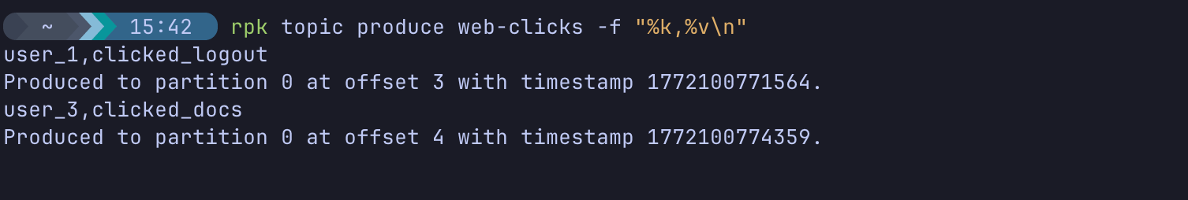
Press Ctrl+C to exit.

Step 2 — Check the Group Status
Instead of consuming the messages, let's ask Redpanda how far behind our consumer group is. Run:
rpk group describe analytics-engine
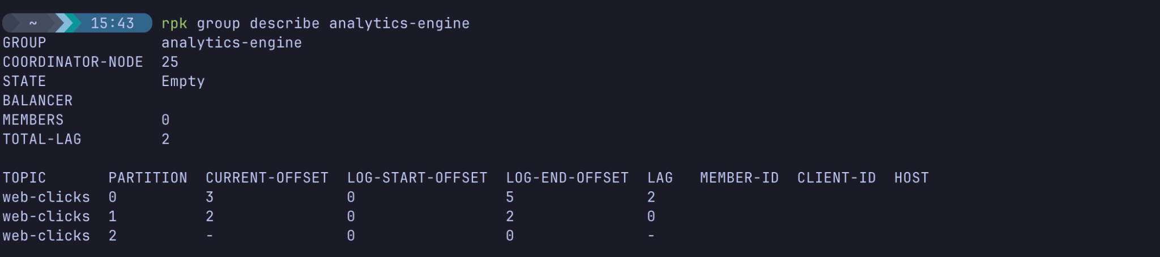
Observe the Output:
Look at the LAG column.
- CURRENT-OFFSET: What the consumer group has successfully processed.
- LOG-END-OFFSET: The latest messages available in the partition.
- LAG: The difference between the two.
Because we produced 2 new messages while the group was offline, you should see a total lag of 2 spread across the partitions.

Step 3 — Catch Up
Start your consumer group one last time:
rpk topic consume web-clicks -g analytics-engine
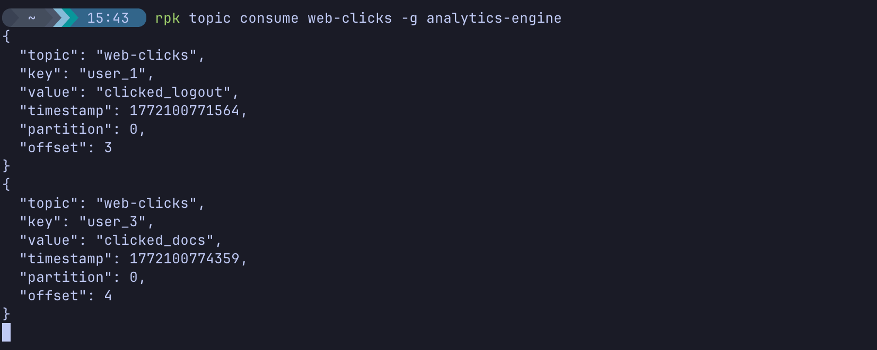
It instantly reads the missing messages, catching up to the end of the log. If you run rpk group describe analytics-engine in another window, the Lag will now be 0.
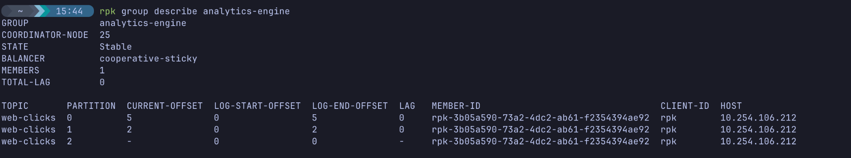

Knowledge Check
- If you have a topic with 3 partitions and you start 4 consumers in the same Consumer Group, what happens to the 4th consumer? (Answer: It sits idle. You can never have more active consumers in a group than you have partitions).
- Why is it important to use a Key when producing messages about a specific user's actions?
- What does "Consumer Lag" represent?
- Where does Redpanda store the saved offsets for a Consumer Group? (Answer: In a special internal topic called __consumer_offsets).

Next Steps
Clean up your Serverless environment by deleting the test topics:
rpk topic delete web-clicks

Conclusion
In this lab, you explored the fundamental routing and scaling mechanisms of Redpanda.
You learned that:
- Partitions allow topics to scale horizontally.
- Message Keys guarantee ordering by consistently hashing to the same partition.
- Consumer Groups allow multiple applications to share reading workloads.
- Offsets ensure that consumer applications can resume safely after a disconnect or crash without dropping or duplicating data.
In upcoming modules, you will learn how to make these partitions highly available (Module 2) and how to transform this data in flight using Redpanda Connect (Module 3).

